**Indian Startups Market**

**Trend Analysis**

**Content**

* Project Objective
* Analytical Goals
* Dataset Attributes
* Tools & Technologies used
* Uncovered key Data-Insights
* Previews (Screenshots of the Project)

**Project Objective:**

The project ‘*Indian Startup Market Trend Analysis*’ aims to understand the Indian Startup Market at a deeper glance by performing exploratory analysis and gathering key data-driven insights by considering the dataset available.

The scope of the data analysis targets to assess key matrices and KPIs including profitability, Acquisitions, growth rate, funding trends across various Tech domains and industries, and social impact attributes like ESG score, Net impact score, and diversity index of companies. The framed analytical goals for the data analysis are tailored by the scope of the project and shaped by the potential of the dataset. These analytical goals and the scope of the objective can broadly be divided into different areas including-

**Area-1: Startup Market Trend Analysis.**

* This analysis focuses on identifying key trends and patterns in the Indian startup ecosystem by evaluating KPIs such as market growth rate, profitability, acquisitions, and founder activity.
* It examines the yearly expansion of the startup market, assesses the geographical distribution of companies, and compares growth rates with GDP contribution to provide a holistic view of the ecosystem.

**Area-2: Investors’ Funding Patterns Analysis.**

* This analysis explores investment and funding patterns in the Indian startup ecosystem, shaped by factors like profitability, technology domains, and industry sectors.
* It examines the yearly funding inflow trends, identifies the tech domains attracting the highest capital, and highlights the key investment behaviors of Indian investors.

**Area-3: Valuation and growth analysis by Industries and Tech domains.**

* This section uncovers high-growth technology domains that drive rapid wealth creation and high market valuations.
* It identifies booming industry-tech combinations, tracks the valuation growth of niche segments, and highlights underperforming sectors, providing a clear picture of which industries are leading or lagging.

**Area-4: Analysis of Social Impact created by the startup market.**

* This analysis evaluates the employment creation potential of various industries and tech domains in the startup ecosystem.
* It examines rapidly evolving technologies, and their potential for customer base expansion, and assesses geographical markets and industry sectors struggling with ESG (Environmental, Social, and Governance) ratings.
* Additionally, it identifies high-impact niche segments based on industry-tech combinations, contributing to overall social and economic impact.

**Area-5: Analyzing market trends across different geographical startup hubs.**

* This section examines regional startup markets, assessing key metrics such as market growth rate, investor concentration, market valuation, and average funding received by startups.
* It provides insights into emerging hubs, high-performing regions, and disparities in funding and investment patterns across different cities.

**Analytical Goals:**

**(Total 35 Analytical Goals or Business Questions)**

**Arear- 1:** Startup Market Trend Analysis

1. Analyze the distribution of startups across key categories such as industries and tech domains.
2. Identify the critical KPIs and metrics that can effectively trace the pattern of startup market trends & performance.
3. Determine India's leading startup hubs or cities by assessing city-wise startup density.
4. Examine the yearly trend in startup formations to understand market growth over time.
5. Identify the industries with the highest startup growth rates and emerging opportunities.
6. Assess the GDP contribution of startups by cities and industries by understanding the revenue potential.

**Arear- 2:** Investors’ Funding Patterns Analysis.

1. Analyze the yearly trend of investment inflow or funding into the Indian startup market.
2. Compare the average funding amounts across different investment stages, from seed funding to IPO.
3. Assess the distribution and range of capital investments across various funding rounds.
4. Identify the top angel investor groups based on their total lifetime investment. (Groups like Mumbai Angles, Delhi Angles, etc)
5. Examine the investment trends of different angel groups, with a focus on funding in profitable vs. loss-making startups.
6. Determine the most preferred industry domains for investors based on total capital invested.
7. Evaluate funding trends over the years for various tech domains to identify emerging investment opportunities.
8. Compare investment range and average funding across different funding types, such as Debt, Equity, and Grants, to assess investor preferences.

**Arear- 3:**  Valuation and growth analysis by Industries and Tech domains.

1. Analyze the yearly valuation trend of startups in the Indian market.
2. Identify underperforming technologies across different industry domains based on valuation and growth metrics.
3. Determine high-growth industry-tech domain combinations by assessing the most effective technology integrations within industries.
4. Identify the technologies that contribute significantly to rapid wealth creation within the startup ecosystem.

**Arear- 4:**  Analysis of Social Impact created by the startup market.

1. Identify the key social impact KPIs associated with the Indian startup market.
2. Analyze the industries generating the highest employment opportunities.
3. Determine the top technology domains contributing to job creation.
4. Assess the technologies that enable higher scalability for startups in terms of customer base expansion.
5. Evaluate technology domains based on ESG (Environmental, Social, and Governance) scores, identifying the highest and lowest-performing domains.
6. Analyze industries with the highest and lowest ESG scores to understand their sustainability impact.
7. Rank Indian startup hubs and cities based on ESG scores, highlighting both top and bottom performers.
8. Identify high-growth technology domains with rapid advancements in research and development, based on patent filings.
9. Assess the net impact patterns across different industry and technology domains, identifying the most influential market segments.

**Arear- 5:**  Analysing market trends across different geographical startup hubs.

1. Identify the key startup hubs in India.
2. Evaluate market growth trends across different startup hub cities.
3. Compare startup density across major startup hubs to assess concentration levels.
4. Identify the cities with the highest percentage of profitable startups.
5. Determine the wealthiest startup hubs based on total market valuation.
6. Analyze the distribution and size of angel investor groups across different cities.
7. Identify cities with the highest total funded capital in the startup ecosystem.
8. Assess which cities attract higher average funding for startups.

**Columns in the dataset:**

1. **Startup_ID =** IDs of startups.
2. **Name =** Name of Startup company.
3. **Sector =** Domain of the startup.
4. **Sub-Sector =** Name of sub-sectors.
5. **City =** City of origin of the Company.
6. **State =** State of origin of the Company.
7. **Founded_Year =** Year when started the Company.
8. **Founder_Name =** Name of Founder
9. **Funding_Stage =** Current Funding Stage
10. **Investment_Type =** Type of investment in the current round.
11. **Amount_Raised =** Amount Raised in the current Round
12. **Investors_Count =** No. of investors invested in the current round.
13. **Lead_Investor =** Name of the Lead Investor.
14. **Co-Investors =** Co-investors joined to the lead one
15. **Valuation_Post_Funding =** Post Money valuation
16. **Revenue =** Current Revenue of the Company.
17. **Profitability =** Is the startup profitable (now)?
18. **Number_of_Employees =** No. of employees.
19. **Tech_Stack =** Primarily Technology of a startup.
20. **Primary_Product =** Name of the primary product (dummy name).
21. **Customer_Base_Size =** Size of the customer base.
22. **Growth_Rate =** Growth Rate of the company.
23. **Exit_Status =** Does the exist happen?
24. **Acquisition_Details =** Details of Acquisition(Yes or No).
25. **Funding_Date =** Date of the recent funding.
26. **Pitch_Deck_Link =** Links of pitches
27. **Social_Media_Followers =** Count of followers on social media.
28. **Competitors =** Name of Competitors.
29. **Patents =** Count of petends.
30. **ESG_Score =** ESG Score of each company.
31. **Diversity_Index =** Diversity Index of each company.
32. **Net_Impact_Score =** Overall Impact Score.

**Tools and Technologies:**

* Microsoft Power BI.
* Microsoft Excel.
* ChatGPT.
* Google Gemini.

**Uncovered Key Data-insights:**

**Area-1: Startup Market Trend Analysis.**

1. The Indian startup ecosystem comprises 12,428 startups, with an average market growth rate of 27.4%. The ecosystem includes 1,000 founders, with approximately 19% of startups acquired by major companies and 50% of founders having exited. Additionally, around 50% of startups in the Indian market are profitable.
2. The startup formation trend has shown a linear increase over time, with a notable acceleration from 2012 onward, indicating heightened entrepreneurial activity.
3. The distribution of startups across major Indian cities highlights Bangalore, Mumbai, and Delhi as the leading startup hubs, based on the following percentage breakdown:

* Bangalore: 17.33%
* Mumbai: 17.26%
* Delhi: 16.64%
* Hyderabad: 16.53%
* Pune: 16.20%
* Chennai: 16.04%

1. The industry's average growth rates indicate FinTech, HealthTech, and AgriTech as the fastest-growing sectors, with the following growth rates:

* FinTech & HealthTech: 27.7%
* AgriTech: 27.5%
* FoodTech: 27.4%
* Retail: 27.3%
* TravelTech & EdTech: 27.2%

1. The Blockchain, Cloud, and AR/VR sectors are witnessing rapid expansion, as reflected in the higher number of startups operating in these technologies.
2. The startup markets in Bangalore, Mumbai, and Delhi make significant GDP contributions, driven by strong revenue-generating performance.
3. The FinTech, AgriTech, and Retail industries demonstrate higher earning potential, as evidenced by their greater contribution to GDP.

**Area-2: Investors’ Funding Patterns Analysis.**

1. The Indian startup market has attracted a total capital investment of approximately Rs. 62.4 billion over the last decade.
2. The Indian startup ecosystem comprises around 500 active investors and angel groups, contributing to the growing funding landscape.
3. On average, Rs. 50 lakh is invested per funding round by investors, with the average funding amounts at different stages as follows:

* Seed Round: Rs. 49.8 lakh
* Series A Round: Rs. 49.6 lakh
* Series B & C Rounds: Rs. 51.1 lakh
* Series D Round: Rs. 50.2 lakh
* IPO Round: Rs. 49.2 lakh

1. Across different funding types, including Debt, Equity, Government Grants, and Convertible Notes, the investment range varies from Rs. 1 lakh to Rs. 1 crore, with an average funding of Rs. 50 lakh.
2. Bangalore, Mumbai, and Hyderabad angel groups are the most significant contributors to startup funding in India, based on their investment track records.

The breakdown of total funded capital by major angel groups is as follows:

* Bangalore Angels: 17.5% (Rs. 10.9 billion)
* Mumbai Angels: 17.2% (Rs. 10.7 billion)
* Hyderabad Angels: 16.5% (Rs. 10.29 billion)
* Delhi Angels: 16.38% (Rs. 10.22 billion)
* Pune Angels: 16.3% (Rs. 10.17 billion)
* Chennai Angels: 16.06% (Rs. 10.02 billion)

1. The highest-funded tech domains include FinTech, TravelTech, and Retail, with the total funded capital across industries as follows:

* FinTech: Rs. 9.31 billion
* TravelTech & Retail: Rs. 9.03 billion each
* AgriTech: Rs. 8.95 billion
* FoodTech: Rs. 8.80 billion
* HealthTech: Rs. 8.77 billion
* EdTech: Rs. 8.52 billion

1. Over the last decade, Blockchain, AR/VR, and IoT startups have experienced a steady increase in funding, highlighting their status as high-growth sectors preferred by investors.

**Area-3: Valuation and growth analysis by Industries and Tech domains.**

1. FinTech, FoodTech, Travel, HealthTech, AgriTech, and EdTech have experienced higher wealth creation and growth, particularly in combination with key tech domains:

* FinTech: Blockchain, Cloud, Big Data
* FoodTech: AI, AR/VR, Blockchain
* TravelTech: AR/VR
* HealthTech: IoT
* AgriTech: Blockchain
* EdTech: AI

1. Over the last decade, Blockchain and Big Data have emerged as the leading tech domains in the development of high-valuation startups.
2. Bangalore and Mumbai are home to startups with the highest valuations and growth, reinforcing their dominance as startup hubs.
3. In recent years, FoodTech, HealthTech, and Retail have demonstrated strong growth, while TravelTech and AgriTech have underperformed in terms of valuation.

**Area-4: Analysis of Social Impact created by the startup market.**

1. Key KPIs for impact analysis indicate the following:

* Average Net Impact Score: 5.5
* Average ESG Score: 5.5
* Average Diversity Index: 50.1%
* Total patents registered by Indian startups: 1,23,096

1. Bangalore, Mumbai, and Hyderabad are the top contributors to employment creation in the startup ecosystem.

**Breakdown of employment created by city hubs-**

* Mumbai: 17.4%
* Bangalore: 17.4%
* Hyderabad: 16.8%
* Delhi: 16.5%
* Pune: 16%
* Chennai: 15.8%

1. Cloud, Blockchain, and AR/VR technologies have enabled startups to scale rapidly by building a larger customer base.
2. Cloud, Blockchain, and AR/VR are among the fastest-growing tech domains, evidenced by their higher patent registrations.
3. Startups in the Retail, HealthTech, and AgriTech sectors are facing challenges in maintaining strong ESG scores.
4. Mumbai and Hyderabad startups tend to have comparatively lower ESG scores than other regions.
5. High-impact startup segments that drive significant societal change combine industry and technology domains:

* EdTech: Cloud, Blockchain, AI
* HealthTech: AR/VR, AI, Cloud
* TravelTech: Cloud, IoT
* Retail: Cloud, AI
* FoodTech: IoT
* AgriTech: AI, IoT

**Area-5: Analyzing market trends across different geographical startup hubs.**

1. Startup density varies across cities, with Pune & Chennai having the lowest density and Bangalore & Mumbai having the highest density of startups.
2. Chennai & Hyderabad exhibit a relatively higher startup growth rate compared to other cities.
3. Pune, Delhi, & Hyderabad have a higher proportion of profitable startups, indicating stronger financial sustainability.
4. Bangalore & Chennai have the highest number of loss-making startups, suggesting potential challenges in financial viability.
5. Most high-valuation startups are concentrated in Bangalore & Mumbai, reinforcing their status as economic hubs.
6. Investor concentration is highest in Delhi, Bangalore, & Hyderabad, making them key cities for startup funding.
7. Bangalore, Mumbai, & Delhi receive the highest funding capital, indicating strong investor confidence in these markets.
8. Delhi startups receive the lowest average funding, suggesting funding disparities across different regions.

**Project Screenshots:**

**Slide-1:** Startup Market Trend Analysis.

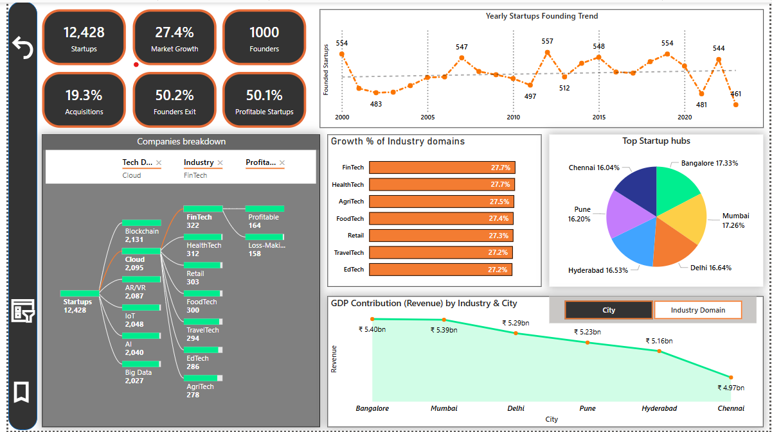

**Slide- 2:** Investors’ Funding Patterns Analysis.

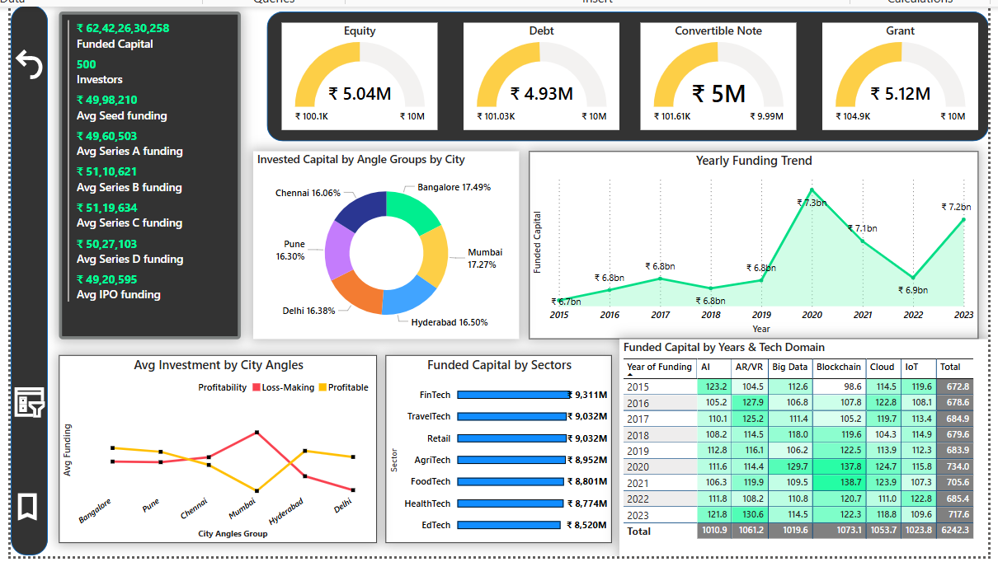

**Slide-3:** Analysis of Social Impact created by the startup market.

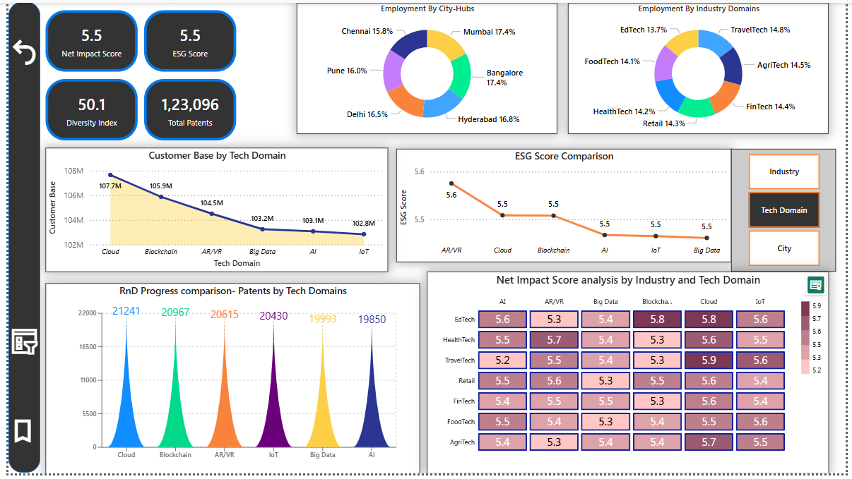

**Slide-4:**

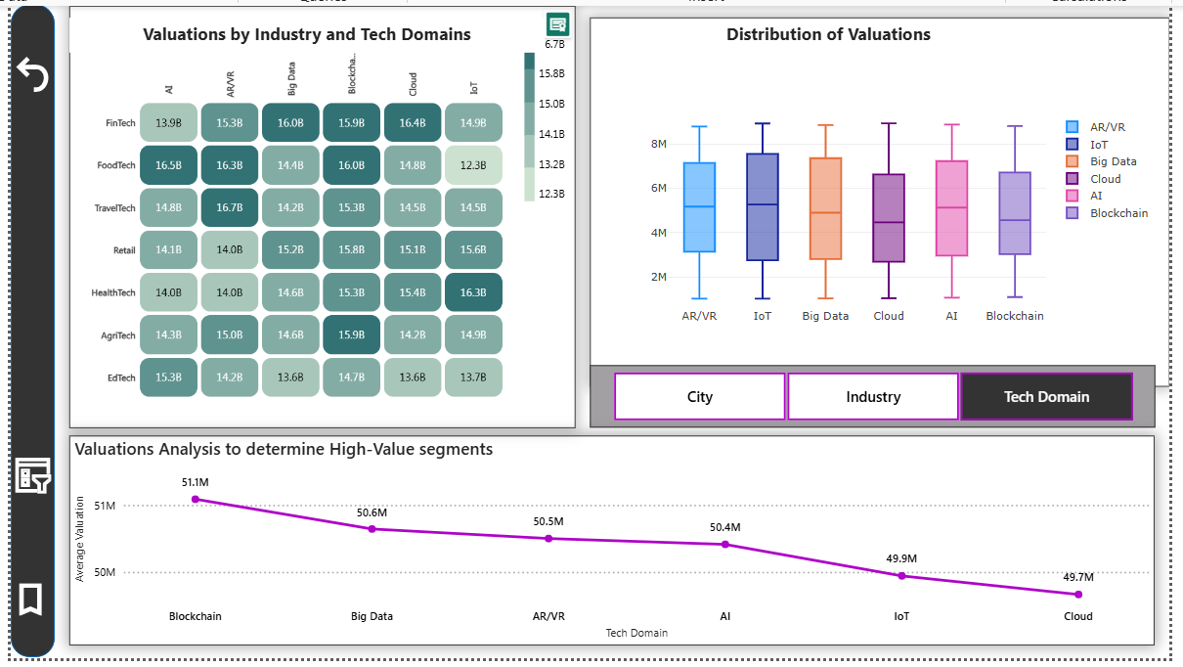

**Slide-5:** Analysing market trends across different geographical startup hubs.

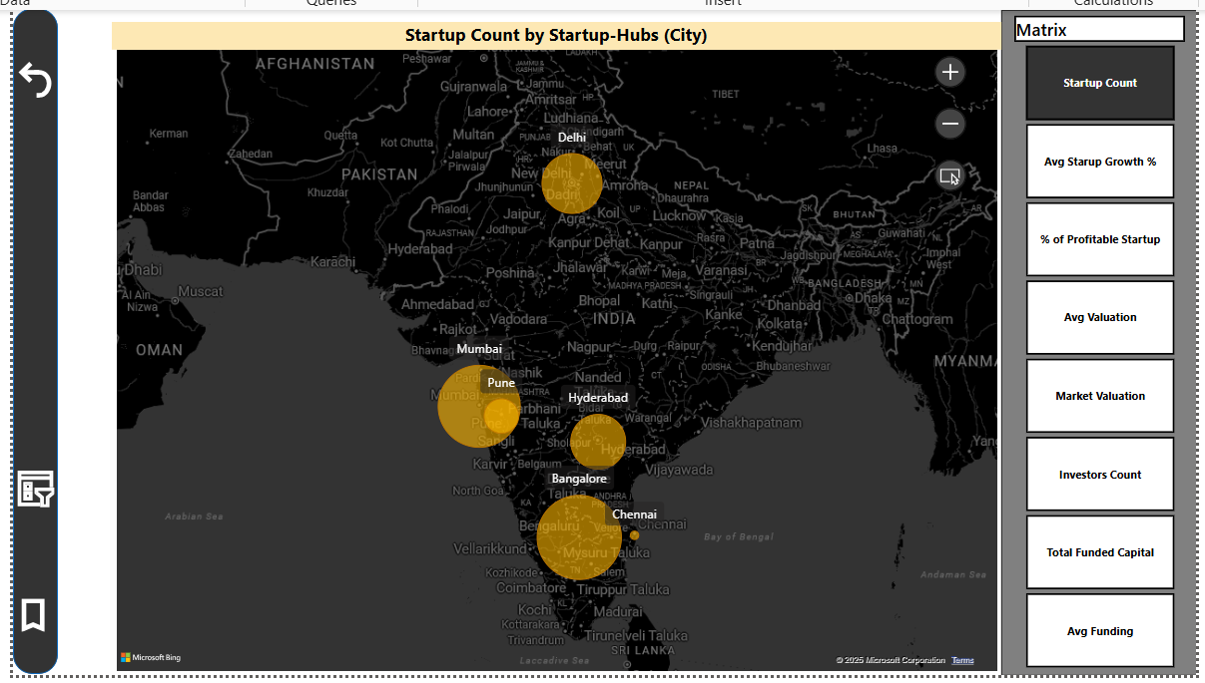

**Filter Pane View:**

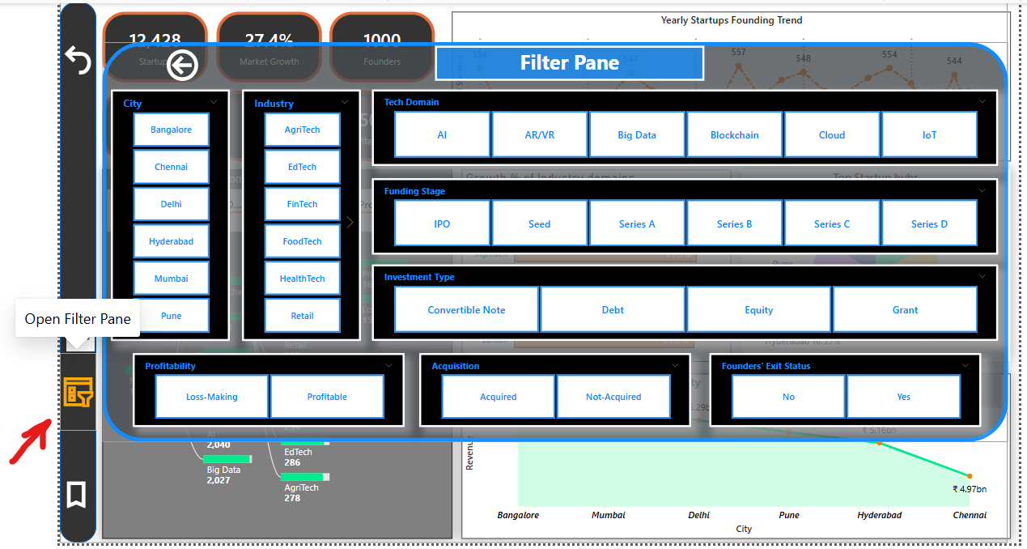

**Page Navigator Pane View:**

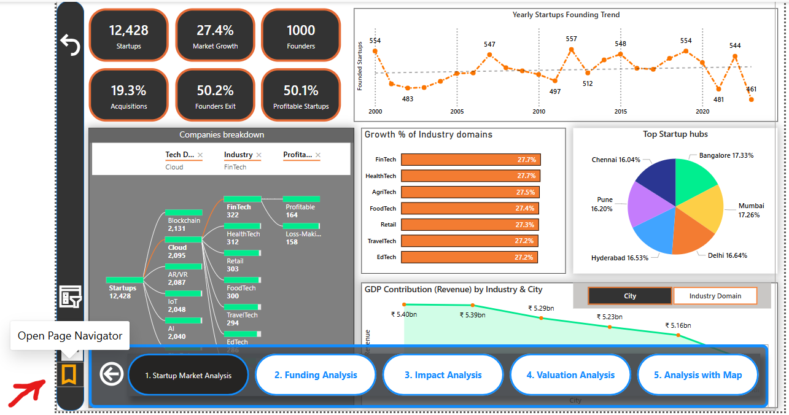

**ToolTips :**



